Area One, Jaguar Drivers Club, February 2025 Newsletter

At our club night on Tuesday 4th February, a small presentation of a bottle of wine and an orchid was made by the new committee to Malcolm Sykes and his wife Jan to thank them for all their hard work during the last four years.
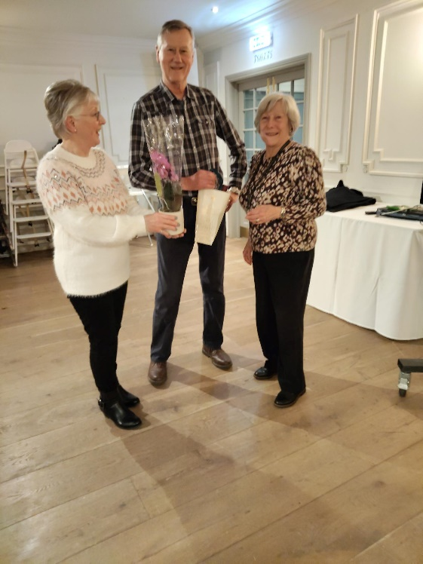

As you know, I have now assumed the role of Chairman and the remainder of the committee have, thank goodness stayed. Sue Parkinson as Vice chairman and Treasurer, together with Lorraine Smith, Caz Varns, Dave Greenly and Mike Resteghini. They have been joined by our new recruit, John May.
We have many events scheduled for the 2025 (please see the calendar on our website at www.jdcarea1.club).
We still have one space available for the gourmet weekend at Sway in the New Forest. We have one double room available on the weekend of the 8/9th of March at a cost of £219.per couple or £189 for single occupancy. If you are interested, please contact Jayne Lawrence at jayne-law@hotmail.co.uk. .
The ‘Drive It Day’ weekend in April is a sell out and it would be great if all members attending this event purchased Childline rally plates which are available from Childline. Please see the advertisement in the J.D.C. magazine for contact details.
There is an additional day out to be added to your calendar which will take place in October and organised by Mr. Left/Right Resteghini. Details will follow in the near future.
As far as 2026 is concerned, we are hoping to organise a tour to the Lot/Garonne region of France in May and a tour to the Isle of Man in September. Details will follow.
Lastly, for those who have forgotten to pay their subs (£15.00 per couple) for 2025, please pay in the usual way to Area 1.
Please remember to wear you lanyards with you names clearly visible at each Area 1 event. It is a great help for new members and all those over 78 years old !!! I attach the template for the badge in case you have lost it.

With best wishes

Tony Eades.

