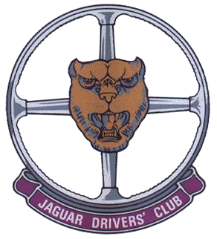
AREA 1 JAGUAR DRIVERS CLUB NEWSLETTER

JANUARY 2022

I have to start this newsletter with the sad news that Phil Parkinson passed away shortly before Christmas.
As you will know, Phil has been unwell for some time now, but that of course doesn’t ease the passing and all of our thoughts must be with Sue and her family at this time.
Phil and Sue have been loyal members of Area 1 for over 20 years, and have been instrumental in organising many of the tours we have enjoyed. Phil was very accomplished on computer software and put together the brochures which accompanied the tour guides with every trip.
Phil’s background was with British Gas, planning engineering works. He left to set up a company with his boss from British Gas and this adventuresome approach and determination showed through in the efforts he put into Area 1. He will be sorely missed.
With this sad news it is difficult to talk about better things, but I think we do need to be very pleased that we squeezed our Christmas dinner in when we did, especially as Omnicron is now causing the cancellation of many such events. The event was a great success; the food was good, the setting was pleasant and the staff very attentive.
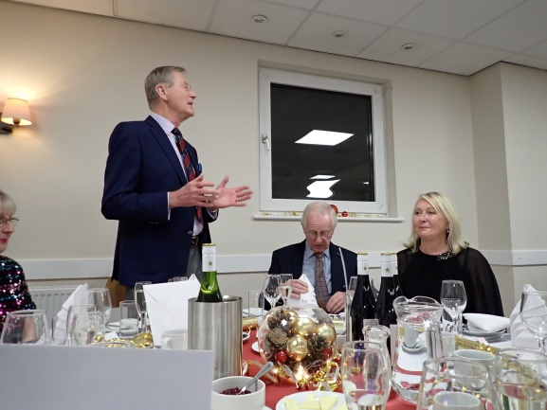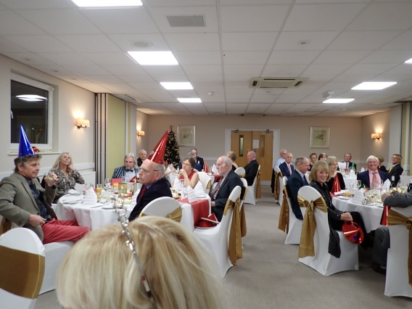

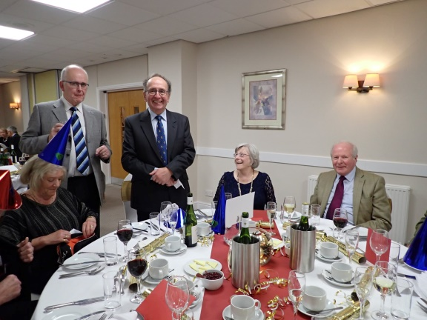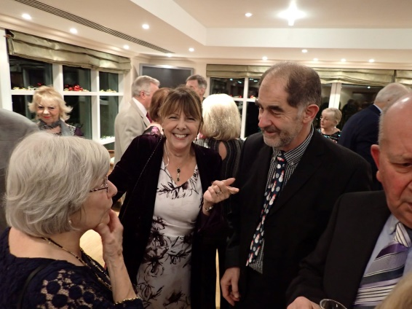

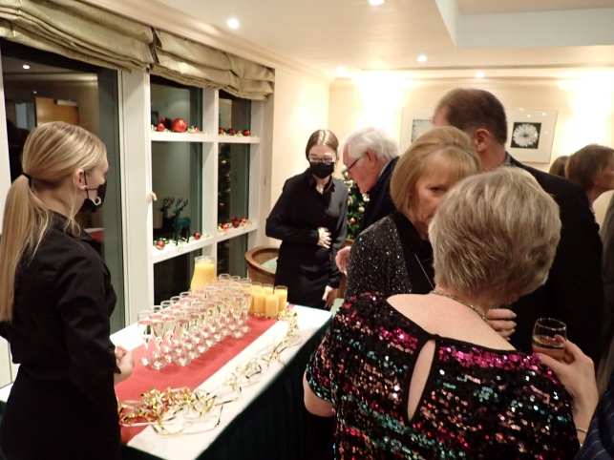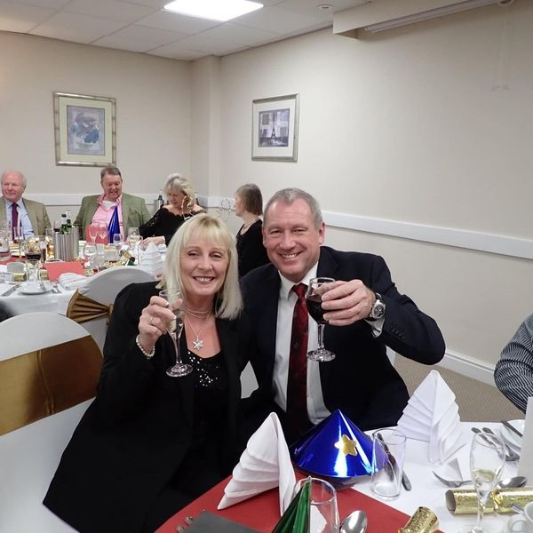

I hope all of you are enjoying the festivities as much as possible, and look forward to seeing you all in the New Year. Let’s hope 2022 brings us many successful gatherings and trips.
Do remember, our next club meeting is at the Vine on January 4th. So do shake off those mince pie tummies and get along!
I will end by reminding you all that subs of £15 per couple/member for 2022 are shortly due. Please pay online to Area 1. Contact me if you don’t have the relevant details.

Best Wishes

Malcolm

Best Wishes

Malcolm

