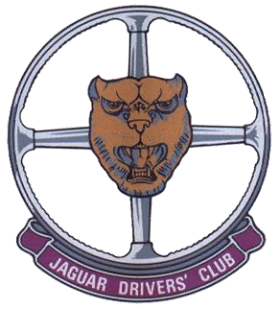
AREA 1 JAGUAR DRIVERS CLUB NEWSLETTER

MAY 2021

AT LAST, the first proper event of this year has taken place with many Area 1 members taking part. I am referring of course to the E Type Register’s Track Day at Goodwood, organised splendidly by Tony Eades, and governed with a stern fist (well, at least a stern voice!) by John Burton.
We feared at one stage that it might be a rain-fueled wash out, but it actually stayed bright and dry although bitterly cold. Even this was a benefit to some, with sales of E Type Register fleeces and coats going well. It was also very windy.
As I was in group 1 in my F Type, and keen to get going, I ended up being first car in the pit lane ready for the off. Things were looking highly promising.
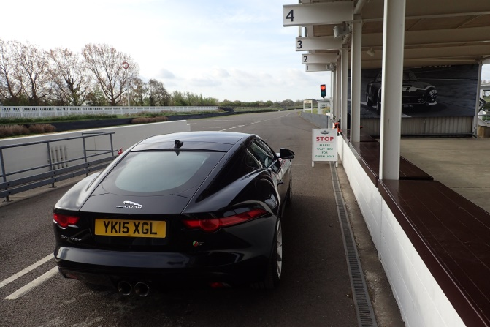
I led group 1 away, and my car performed magnificently. It hugged the corners well and was very fast in the straights. The day didn’t end quite so well for me though. This is my car ready to leave Goodwood:
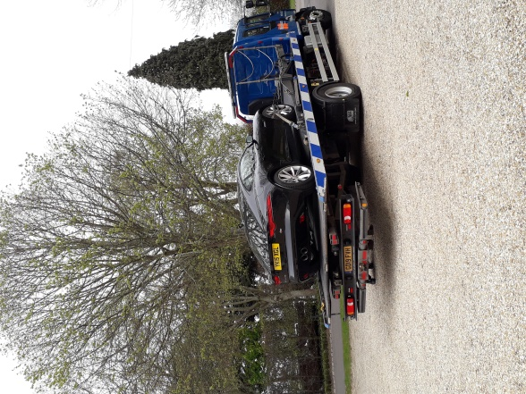
Sadly, at the end of the first session, it started running on just 5 cylinders, with (according to the car following me) spectacular 2 foot long sheets of flames coming from the exhaust. Still, the insurance rescue people got me home reasonably quickly and efficiently, and the car is booked in for a week’s time under (hopefully!) warranty.
Mike Resteghini had a better day in his wonderfully prepared black E Type. Mike has developed it to “fast road” spec, and it performed very well, more than keeping up with cars which on paper should have been much quicker.
Another well prepared E Type was this one, driven by a 6 year old!
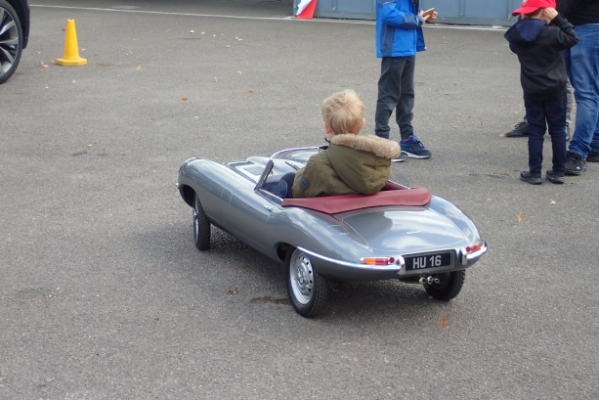
It was built from scratch by his father, an aero engineer. The lad drives it sometimes on the circuit, and it can reach speeds up to 45mph!

Look out for more pics on our website, https://jdcarea1.club
Our next big event is our drive out day to Weymouth and the Nothe Fort, which is fully subscribed with an overnight hotel stay.
This of course is followed by our Popham Flying Day. I make no apology for advertising this event strongly. Numbers booked are rising nicely, but we really need you there – we have to have adequate numbers to justify the cost of the great Hog Roast that is put on for us, as well as the extraordinary apple tart supplied by Tony. Just £15 brings you this together with a heady mix of cars and planes – and of course great company! Here’s the details:
STOP PRESS!!
Tickets for Flying Day on 27th June are now on sale. They cost £15.00 per head to
include a Hog Roast, salad and a dessert and of course the opportunity to take a flight
in one of the planes that will be available for a contribution of £25.00 towards fuel costs
for the pilots. Tickets for the event must be purchased in advance (there will be no ticket
sales on the day) so please contact Caz Varns at cazvarns@icloud.com or 07762 907715,
with details of how many tickets you will require and send payment. Bring your family
and friends along for a great day out. Participants do not have to be members
of the Club.

With regards to our other events, the Wallop Wheels and Wings day is now full, with no more cars able to enter the paddock with our Area 1 group. You can however still come on the day, park in the normal public area and join us.

Both the Welsh and European trips are nearly full, with just a couple of rooms left, so if you wish to attend you will need to book soon following the information previously sent to you. If you don’t have that, then do contact me.

This brings me on to our forthcoming Club meetings. We will not be able to hold our June meeting at the Vine, even outside, as the pub has informed us they can’t do that until after June 21st when restrictions are eased. However, we do hope and expect to see you all there on Tuesday July 6th. I will of course update you with details about that nearer the time.

Best wishes to you all,

Malcolm

